# CSS Exercise

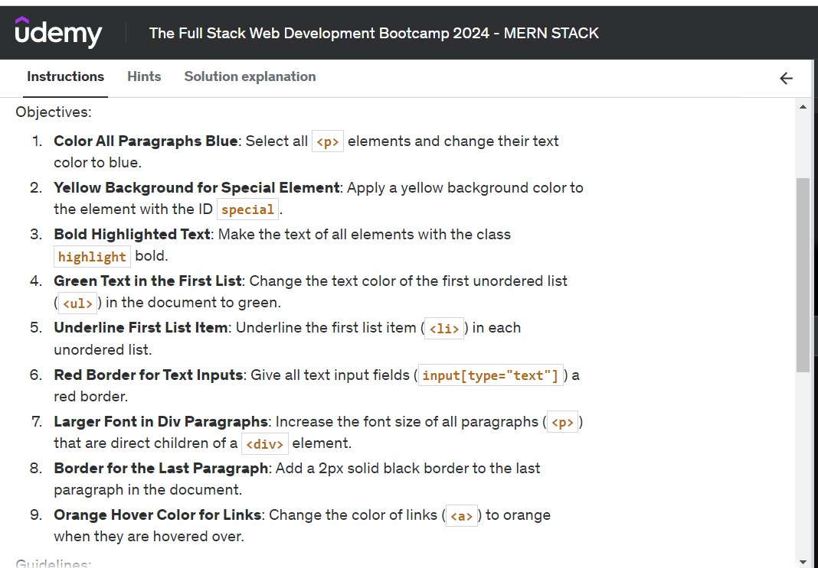  
  
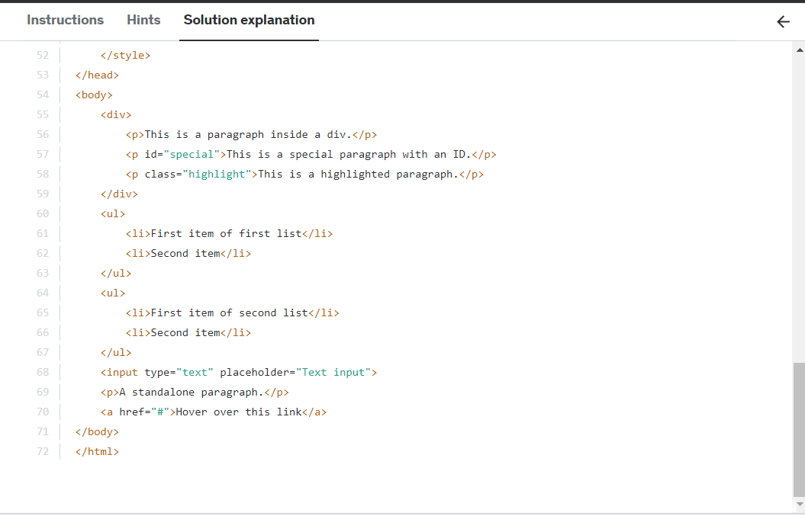  
  
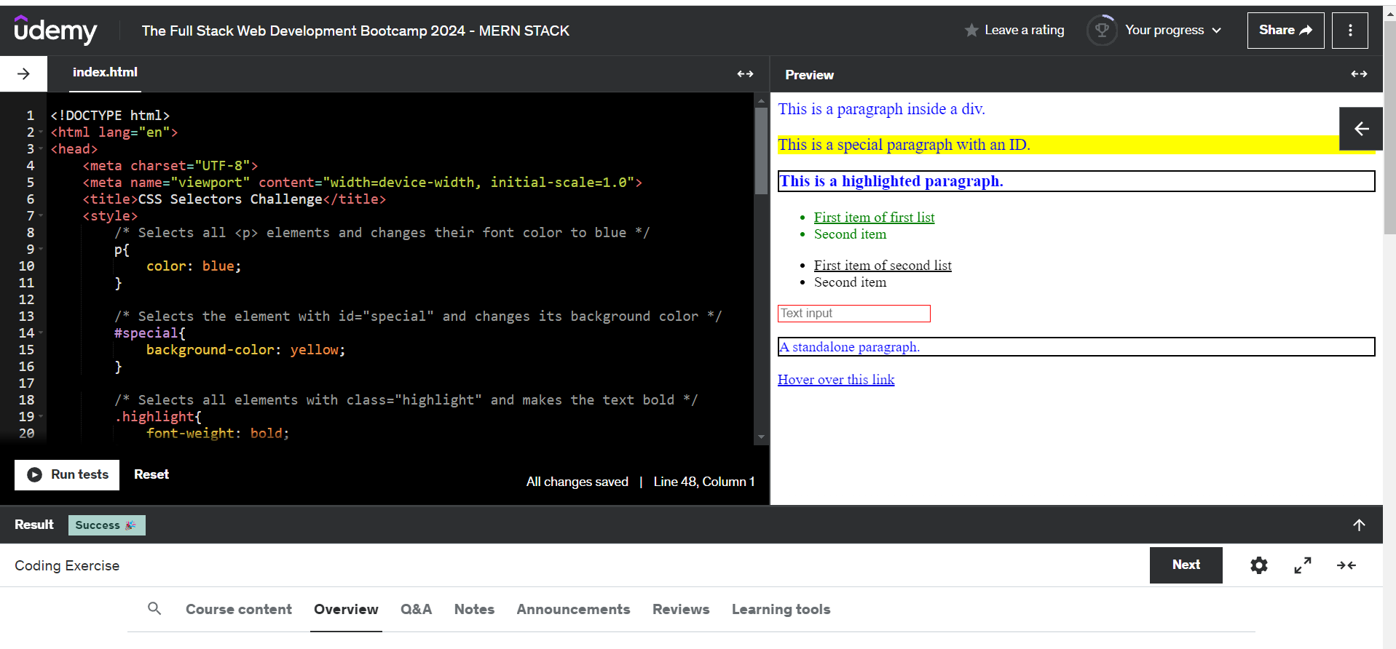

# Exercise 2 A screenshot of a computer Description automatically generated Exercise 3

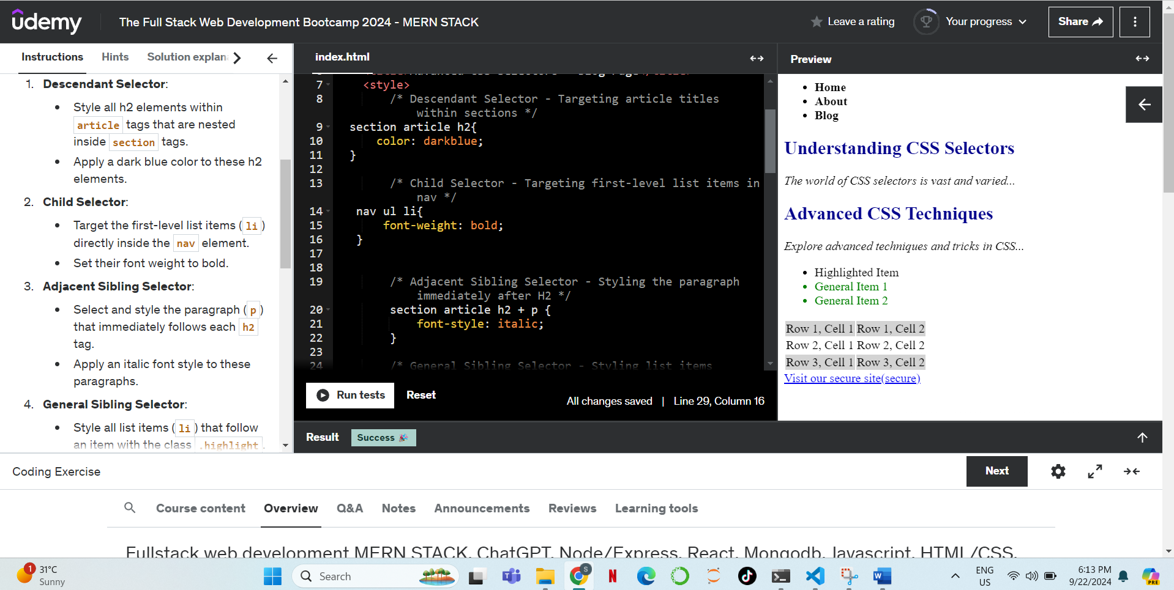  
Attribute selector

<https://www.w3schools.com/css/css_attribute_selectors.asp>

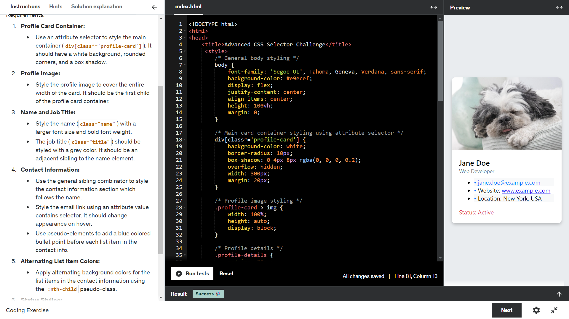  
  
POSITIONING:  
Static(Default)  
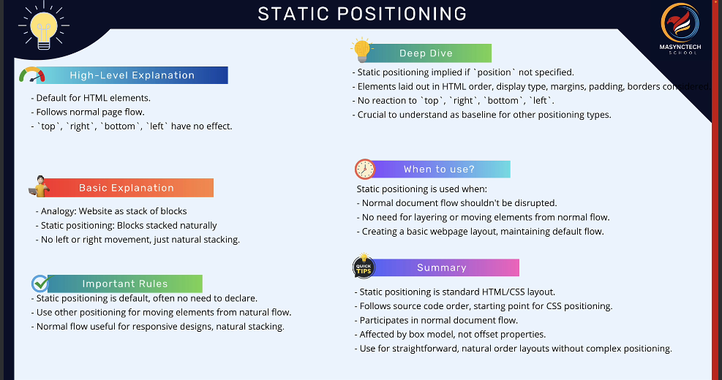

# Absolute(w.r.t view port) A screenshot of a computer Description automatically generated Relative Positioning A screen shot of a product Description automatically generated Parent of promo-banner is product-image A screenshot of a computer program Description automatically generated A screen shot of a computer and a pen Description automatically generated A screenshot of a product page Description automatically generated A computer and pen on a desk Description automatically generated A computer and pen on a table Description automatically generated A screenshot of a computer program Description automatically generated A computer and pen on a desk Description automatically generated

# Fixed

# 